*of Rock, Walworth & Jefferson Counties*

1545 Hobbs Drive / PO Box 655

Delavan, WI 53115 or 262.728.8865

bbbs4kids.org ~ mikeg@bbbs4kids.org

Phone: 262-728-8865

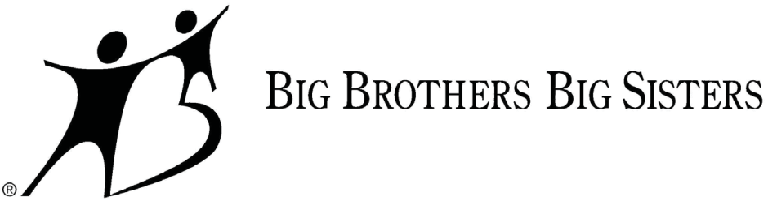

**BOWL FOR KIDS’ SAKE**

**2016 Bowler Information**

Bowl For Kids’ Sake (BFKS) is about having fun to help “Kid’s” continue on a positive path. It is Big Brothers Big Sisters’ largest national fundraiser, raising over $20 million annually for children in need across the country. By supporting BFKS locally, you can *Start Something* in your community ~ more Big’s and Little’s can be paired up, more friendships can be gained, and improved outlooks on life can be started.

BFKS is a fun and easy way to positively impact a child’s life. Just follow these simple steps below:

1. **Start a Team**. Teams are formed with up to six members. Consider creating a team with family, friends, co-workers, your match or anyone interested in making a difference through supporting youth mentoring! If you don’t have 6 members, no worries...we’ll match you up with other bowlers to complete your squad!

2. **Start Planning**. Register yourself or your team(s) (call 262-728-8865, mail, or email to mikeg@bbbs4kids.org) **by April 4th**. A Team Registration Form (and all the forms) can be found at [www.bbbs4](http://www.bbbs4kids.org/)kids.org. For your convenience, we have multiple events to choose from: Friday, April 8th at 6:30p (Fort Atkinson), Saturday, April 9th at 4p and 7p (Delavan), and Saturday, April 16th at 4p & 7p (Janesville). Lanes fill up fast, so secure your team’s spot early!

3. **Start Securing Pledge Sponsors**. Bowler entry fee is $30 each ($15 for youth under 16) to participate. Each bowler will receive 2 games of bowling, shoe rental, event t-shirt, soda and pizza. **Bowlers are encouraged to instead raise pledges so there is no out-of-pocket expense to you.** **Each bowler raising $100 or more in pledges will get an entry into the GRAND RAFFLE! $250 or more in pledges will also receive a BBBS hooded sweatshirt! Reaching $100 is easy...just think of it as asking ‘10 friends or family to support your efforts with a minimum $10 pledge’ (individual bowlers raising $100 or MORE in pledges will have the bowler entry fee of $30 waived). You can use either a paper pledge sheet or our user friendly on-line pledge page (PayPal) at** [**www.bbbs4kids.org**](http://www.bbbs4kids.org) **(click on the Donate Now button to continue). Many bowlers who use this great web based tool increase their pledge goal by over 100%! Create an email and share a story on why you believe in the BBBS mission on your pledge page and watch the pledges roll in ~ no face-to-face asking! It’s as easy as emailing the** [**www.bbbs4kids.org**](http://www.bbbs4kids.org) **link to your contacts!**

4. **Start Bowling**. After you have registered yourself or your team(s), it’s time to have fun! Join the party on Saturday, April 9th at Delavan Lanes (or one of the other dates) to celebrate youth mentoring and your achievement of raising pledges!! You’ll receive 2 games of bowling, shoe rental, event t-shirt, soda and pizza as part of the fun night! A 50/50 raffle and prize raffle will be going on all evening too!

So, what are you waiting for? Partnering with Big Brothers Big Sisters through Bowl For Kids’ Sake makes a positive, long-lasting impact on children in your community. Our mentoring works. It works to help broaden children’s perspectives and help them learn how to make good choices. It starts a child on the path to fulfilling their potential ~ and succeeding in school and life.

**2016 Bowl For Kids’ Sake**

**April 9th ~ 4p & 7p at Delavan Lanes / Delavan**

**262-728-8865 ~** [**mikeg@bbbs4kids.org**](mailto:mikeg@bbbs4kids.org) ***Check out bbbs4kids.org* *for* *your* *Team Registration Form, Paper Pledge Sheet & information***