
FREE
FAMILY
ACTIVITIES
East Troy Family Community Resource Center
3066 Main Street, Suite 108–Windfield Plaza
642-4900
easttroyfamily@gmail.com
www.easttroyfamily.webs.com
Program Director: Marolyn Komperud
Find Us on Facebook

MARCH EVENTS
Alphabet Adventures– Every Tuesday we will hold a pre-school class called Alphabet Adventures. Each week we will focus on a different number for the remainder of the school year. In March, we will be covering the letters X, Y, Z and the number 1. Each week we will try to incorporate different skills such as cutting, coloring, counting, pasting, color and shape recognition in addition to learning a new letter. Please pre-register by the Monday prior. It is not necessary to attend every class. This class is appropriate for ages 2-5 and takes place from 9:30 to 10:00 a.m.
Wednesday Play Group: A playgroup for children age five and under will be held every Wednesday from 9:30-10:30 a.m. during the school year. This is a great time for little ones to socialize and learn the valuable lessons of sharing, cooperation and fair play. This also provides caregivers an opportunity to connect with other parents and caregivers in the community. Come join the fun! This is a free program and there is no need to register.
Crafty Kids-Thursday March 9th- Shamrock Hand Print Wall Hanging- We will be making a painted hands shamrock wall hanging just in time for St. Patrick's Day. We need a minimum of five registered participants to hold the class. You can register on the event on our Facebook page, by calling or e-mail. Please indicate the number of children attending. We will be using paint so please dress kids accordingly! This class will take place from 5:30 to 6:00 p.m. Please pre-register by Thursday March 2nd.
Adult Craft - Thursday March 16th- We will be making a DIY Easter Egg wreath, perfect to start your holiday decorations. All of the supplies will be provided to create a cute wreath to decorate your door or home. For the bargain price of $20 we will provide all of the supplies need, instruction, great company, snacks and non-alcoholic beverages! You are welcome to bring in any beverage of your choosing. So bring your girlfriends for a fun night out! Due to the limited spacing at the center, this is a reserved event only! Only 20 spaces are available for this one-time event. Please pre-register on our events page or by calling 642-4900 or e-mailing eastroyfamily@gmail.com and then sending or dropping off your $20 payment to the East Troy Family Community Resource Center, 3066 Main Street, PO Box 962, East Troy, WI 53120. Payment is needed by March 12th to secure your spot.
We ask that anyone interested in participating in one or more of our events please pre-register by contacting our Program Coordinator, Marolyn Joas-Komperud, at 642-4900 or e-mailing easttroyfamily@gmail.com . Pre-registration is needed to ensure that we have enough supplies to accommodate everyone.
All of the events listed above are provided free of charge and are open to East Troy residents as well as families from our surrounding communities. We look forward to seeing you!
The East Troy Family Community Resource Center is a 501(C) (3) non-profit organization.
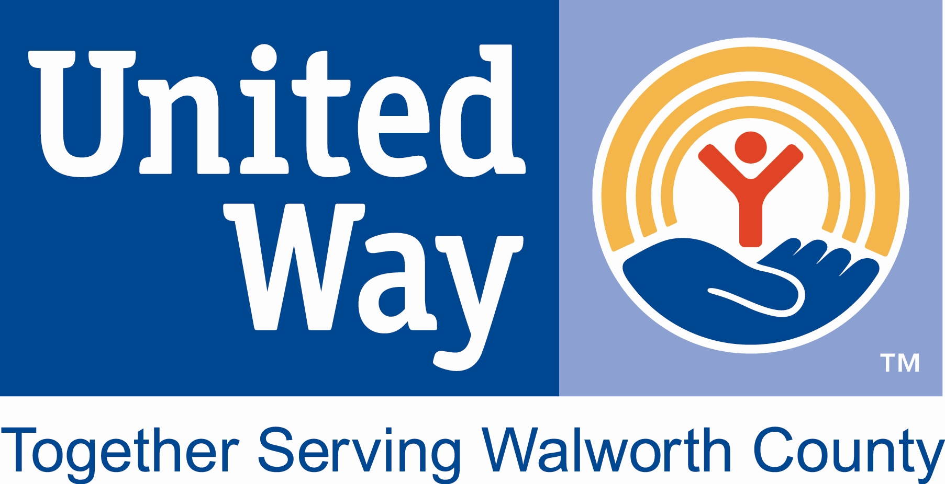
The East Troy School District is not affiliated nor provides financial support for this activity/promotion.

