Wine and Winter Spirits Canvas Painting

Come learn step to step directions with Lauren Babcock on how to paint this adorable snowman!

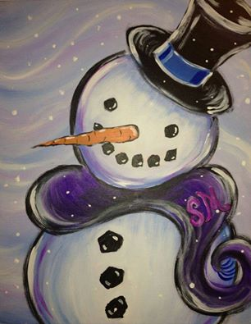

Join us for a Wine & Winter Spirits Canvas Painting
here at East Troy Snap Fitness on Nov 20th
Doors open at 6:15pm, but painting will begin right away at 6:30pm!
We will each get to paint a canvas with Lauren Babcock leading us through step-by-step (while sipping our wine of course ;)
Space is limited though so RESERVE YOUR SPOT ASAP!
*PRE PAYMENT IS REQUIRED TO ENSURE WE HAVE SUPPLIES FOR YOU!* $35 (deadline is November 14th payable to Snap Fitness)
It is going to be a fun evening with some amazing people!! Please bring your favorite bottle of wine to share.

Light snacks, plastic wine glasses, all paint and canvas will be provided.

